**AMITY SCHOOL OF ENGINEERING & TECHNOLOGY**

AMITY UNIVERSITY CAMPUS, SECTOR-125, NOIDA-201303



**Exploring the Networks Lab**

PRACTICAL FILE

COURSE CODE: IT307

Submitted to: Submitted by:

Prof.(Dr.) Tanya Sigh Boddu Asmitha Bhavya

A2305221386

5CSE-6X

***INDEX***

|  |  |  |  |  |
| --- | --- | --- | --- | --- |
| **S.No** | **Experiment Name** | **Date of Allocation** | **Date of Submission** | **Signature** |
| 1. | Know your devices |  |  |  |
| 2. | To Configure initial Switch Settings |  |  |  |
| 3. | To implement basic connectivity |  |  |  |
| 4. | Basic switch and end device configuration |  |  |  |
| 5. | To connect the physical layer |  |  |  |
| 6. | To examine ARP Table. |  |  |  |
| 7. | To View Network Device MAC Addresses. |  |  |  |
| 8. | To View the Switch MAC Address Table. |  |  |  |
| 9. | To perform basic and initial router configuration |  |  |  |
| 10. | To connect a router to a LAN |  |  |  |
|  |  |  |  |  |
|  |  |  |  |  |
|  |  |  |  |  |
|  |  |  |  |  |
|  |  |  |  |  |
|  |  |  |  |  |
|  |  |  |  |  |

**EXPERIMENT 6**

**AIM:**

To examine ARP Table.

**Software Used**:

Cisco Packet Tracer

**Objectives:**

Part 1: Examine an ARP Request

Part 2: Examine a Switch MAC Address Table

Part 3: Examine the ARP Process in Remote Communications

**Topology**:

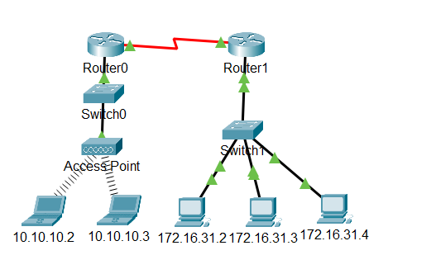

**Addressing Table-**

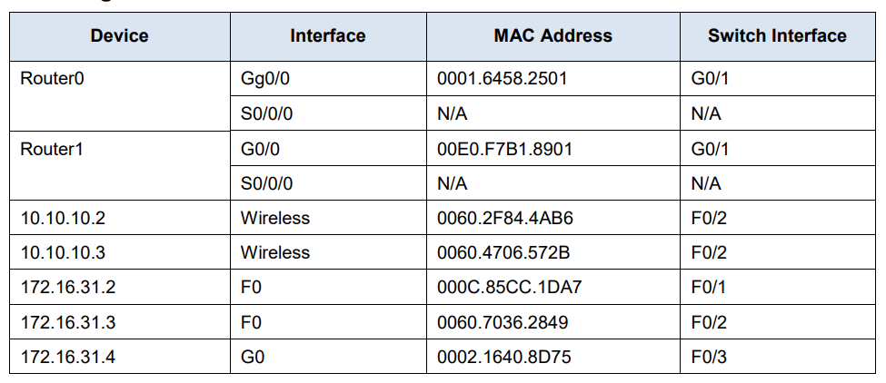

**Questions**:

1. What is the IP address of the device that accepted the PDU?

Ans 172.16.31.3

1. What happened to the source and destination MAC addresses?

Ans Source became destination, FFFF.FFFF.FFFF turned into MAC address of 172.16.31.3

1. How many copies of the PDU did the switch make during the ARP reply?

Ans 1

1. Do the MAC addresses of the source and destination align with their IP addresses?

Ans Yes

1. To what IP address does the MAC address entry correspond?

Ans 172.16.31.3

1. In general, when does an end device issue an ARP request?

Ans When it does not know the receiver’s MAC address.

**Procedure:**

**Part 1**: Examine an ARP Request

Step1: Generate ARP requests by pinging 172.16.31.3 from 172.16.31.2. Open a command prompt a. Click 172.16.31.2 and open the Command Prompt.

b. Enter the arp -d command to clear the ARP table. Close a command prompt

c. Enter Simulation mode and enter the command ping 172.16.31.3. Two PDUs will be generated. The ping command cannot complete the ICMP packet without knowing the MAC address of the destination. So the computer sends an ARP broadcast frame to find the MAC address of the destination.

d. Click Capture/Forward once. The ARP PDU moves Switch1 while the ICMP PDU disappears, waiting for the ARP reply. Open the PDU and record the destination MAC address.

e. Click Capture/Forward to move the PDU to the next device.

f. Open the PDU and examine Layer 2.

g. Click Capture/Forward until the PDU returns to 172.16.31.2.

Step 2: Examine the ARP table.

1. Note that the ICMP packet reappears. Open the PDU and examine the MAC addresses.
2. Switch back to Realtime and the ping completes. c. Click 172.16.31.2 and enter the arp –a command

**Part 2:** Examine a Switch MAC Address Table

Step 1: Generate additional traffic to populate the switch MAC address table. Open a command prompt .

a. From 172.16.31.2, enter the ping 172.16.31.4 command.

b. Click 10.10.10.2 and open the Command Prompt.

c. Enter the ping 10.10.10.3 command

Step 2: Examine the MAC address table on the switches

1. Click Switch1 and then the CLI tab. Enter the show mac-address-table command.
2. Click Switch0, then the CLI tab. Enter the show mac-address-table command.

**Part 3**: Examine the ARP Process in Remote Communications

Step 1: Generate traffic to produce ARP traffic. Open a command prompt

a. Click 172.16.31.2 and open the Command Prompt.

b. Enter the ping 10.10.10.1 command.

c. Type arp –a

d. Enter arp -d to clear the ARP table and switch to Simulation mode

e. Repeat the ping to 10.10.10.1.

f. Click Capture/Forward. Click the PDU that is now at Switch1.

g. The destination IP address is not 10.10.10.1.

Step 2: Examine the ARP table on Router1.

a. Switch to Realtime mode. Click Router1 and then the CLI tab.

b. Enter privileged EXEC mode and then the show mac-address-table command.

c. Enter the show arp command.

**Result:**

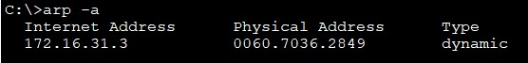

**Evaluation Table:**

|  |  |  |  |
| --- | --- | --- | --- |
| **Criteria** | **Total Marks** | **Marks Obtained** | **Comments** |
| Concept (A) | 2 |  |  |
| Implementation (B) | 2 |  |  |
| Performance (C) | 2 |  |  |
| Total | 6 | | |

**EXPERIMENT 7**

**AIM:**

To View Network Device MAC Addresses.

**Software Used**:

Cisco Packet Tracer

**Objectives**:

Part 1: Configure Devices and Verify Connectivity.

Part 2: Display, Describe, and Analyse Ethernet MAC Addresses.

**Topology**:

**Addressing Table**:

**Questions:**

1. What is the serial number portion of the MAC address for this device?

Ans 24-2A-60

1. What is the MAC address for VLAN 1 on S1?

Ans 001b.0c6d.8f40

1. What is the MAC serial number for VLAN 1?

Ans 6d-8f-40

1. What is the OUI for VLAN 1?

Ans 00-1b-0c

1. Based on this OUI, what is the name of the vendor?

Ans Cisco Systems

1. What does bia stand for?

Ans Burned in address

1. Why does the output show the same MAC address twice?

Ans The MAC address can be changed via a software command. The actual address (bia) will still be there. It is shown in the parenthesis.

1. What Layer 2 addresses are displayed on S1?

Ans S1 VLAN 1 and PC-A MAC addresses.

1. What Layer 3 addresses are displayed on S1?

Ans S1 and PC-A IP addresses.

**Procedure:**

Part 1: Configure Devices and Verify Connectivity In this part, you will set up the network topology and configure basic settings, such as the interface IP addresses and device name. For device name and address information, refer to the Topology and Addressing Table.

Step 1: Cable the network as shown in the topology

a. Attach the devices shown in the topology and cable as necessary.

b. Power on all the devices in the topology.

Step 2: Configure the IPv4 address for the PC

a. Configure the IPv4 address, subnet mask for PC-A.

b. From the command prompt on PC-A, ping the switch address.

Step 3: Configure basic settings for the switch. In this step, you will configure the device name and the IP address, and disable DNS lookup on the switch.

1. Console into the switch and enter global configuration mode.
2. Assign a hostname to the switch based on the Addressing Table.
3. Disable DNS lookup.
4. Configure and enable the SVI interface for VLAN 1.



Step 4: Verify network connectivity. Ping the switch from PC-A

Part 2: Display, Describe, and Analyze Ethernet MAC Addresses

Step 1: Analyze the MAC address for the PC-A NIC.

Before you analyze the MAC address on PC-A, look at an example from a different PC NIC. You can issue the ipconfig /all command to view the MAC address of your NIC.

Step 2: Analyze the MAC address for the S1 F0/6 interface. You can use a variety of commands to display MAC addresses on the switch. a. Console into S1 and use the show interfaces vlan 1 command to find the MAC address information. A sample is shown below. Use output generated by your switch to answer the questions.

b. Another way to display the MAC address on the switch is to use the show arp command. Use the show arp command to display MAC address information. This command maps the Layer 2 address to its corresponding Layer 3 address. A sample is shown below. Use output generated by your switch to answer the questions.

Step 3: View the MAC addresses on the switch. Issue the show mac address-table command on S1. A sample is shown below. Use output generated by your switch to answer the questions.

**Result**- Hence, we viewed the Network Device MAC Address.

**Evaluation Table:**

|  |  |  |  |
| --- | --- | --- | --- |
| **Criteria** | **Total Marks** | **Marks Obtained** | **Comments** |
| Concept (A) | 2 |  |  |
| Implementation (B) | 2 |  |  |
| Performance (C) | 2 |  |  |
| Total | 6 | | |

**EXPERIMENT 8**

**AIM:**

To View the Switch MAC Address Table.

**Software Used**:

Cisco Packet Tracer

**Topology**-

**Addressing Table**-

**Objectives**-

**Part 1:** Build and Configure the Network

**Part 2:** Examine the Switch MAC Address Table

**Questions :**

1. What are the Ethernet adapter physical addresses?

Ans PC-A MAC Address- 00-50-56-B3-27-D6

PC-B MAC Address- 00-50-56-B3-FF-54

1. Does the MAC address table have any addresses in it for VLAN 1? Are there other MAC addresses listed?

Ans No, it is discovered that the MAC address for the other switch’s F0/1 switch port has been quickly reinserted in the MAC address table.

1. Are there new addresses in the MAC address table?

Ans Answers will vary .

**Procedure:**

**Part 1: Build and Configure the Network**

Step 1: Cable the network according to the topology.

Step 2: Configure PC hosts.

Step 3: Initialize and reload switches as necessary.

Step 4: Configure basic settings for each switch.

a. Configure device name as shown in the topology.

b. Configure IP address as listed in Addressing Table.

c. Assign cisco as the console and vty passwords.

d. Assign class as the privileged EXEC password.

**Part 2: Examine the Switch MAC Address Table** A switch learns MAC addresses and builds the MAC address table, as network devices initiate communication on the network.

Step 1: Record network device MAC addresses.

a. Open a command prompt on PC-A and PC-B and type ipconfig /all.

b. Console into switch S1 and S2 and type the show interface F0/1 command on each switch.

Step 2: Display the switch MAC address table. Console into switch S2 and view the MAC address table, both before and after running network communication tests with ping.

a. Establish a console connection to S2 and enter privileged EXEC mode. Open a configuration window.

b. In privileged EXEC mode, type the show mac address-table command and press Enter.

Step 3: Clear the S2 MAC address table and display the MAC address table again

a. In privileged EXEC mode, type the clear mac address-table dynamic command and press Enter. S2# clear mac address-table dynamic

b. Quickly type the show mac address-table command again.

Step 4: From PC-B, ping the devices on the network and observe the switch MAC address table. a. From PC-B, open a command prompt and type arp -a.

b. From the PC-B command prompt, ping PC-A, S1, and S2.

c. From a console connection to S2, enter the show mac address-table command.

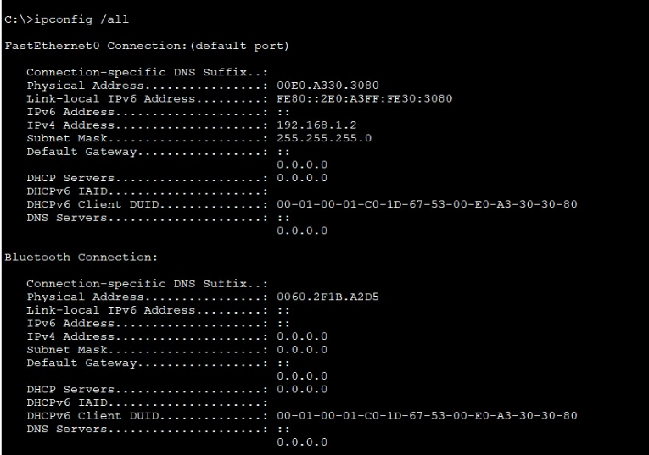

Result- Hence, we viewed the Switch MAC Address Table.

**Evaluation Table: -**

|  |  |  |  |
| --- | --- | --- | --- |
| **Criteria** | **Total Marks** | **Marks Obtained** | **Comments** |
| Concept (A) | 2 |  |  |
| Implementation (B) | 2 |  |  |
| Performance (C) | 2 |  |  |
| Total | 6 | | |

**EXPERIMENT 9**

**Aim:**

To perform basic and initial router configuration

**Devices Used**:

Router, PCs, and Console Cable.

# Objectives:

Part 1: Verify the Default Router Configuration

Part 2: Configure and Verify the Initial Router Configuration Part 3: Save the Running Configuration File

# Questions:

**Q) What is the router’s hostname?**

Ans) Router

# Q) How many Fast Ethernet interfaces does the Router have?

Ans) none

# Q) How many Gigabit Ethernet interfaces does the Router have?

Ans) 2

# Q) How many Serial interfaces does the router have?

Ans) 2

# Q) What is the range of values shown for the vty lines?

Ans) 0-4

# Q) What command do you use to verify initial conﬁguration on router?

Ans) show running-config

# Q) Why should every router have a message-of-the-day (MOTD) banner?

Ans) Every router should have a banner to warn unauthorized users that access is prohibited. MOTD Banners can also be used to send messages to network personnel (such as impending system shutdowns or who to contact for access).

# Q) f you are not prompted for a password before reaching the user EXEC prompt, what console line command did you forget to conﬁgure?

Ans) R1(config-line)# login

# Q) If you conﬁgure any more passwords on the router, are they displayed in the conﬁguration ﬁle as plain text or in encrypted form? Explain.

Ans) The service password-encryption command encrypts all current and future passwords.

# Q) What command did you enter to save the conﬁguration to NVRAM?

Ans) copy running-config startup-config

# Q) Which command displays the contents of the NVRAM?

Ans) show startup-configuration or show start

In this activity, you will perform basic router configuration tasks. You will secure access to the CLI and console port using encrypted and plain-text passwords. You will also configure messages for users who are logging into the router. These banners warn unauthorized users that access is prohibited. Finally, you will verify and save your running configuration.

# Topology:

**Procedure**:

**Part 1: Verify the Default Router Configuration**

**Step 1: Establish a console connection to R1**.

Router> enable

Router# show running-config Router# show startup-config Router# configure terminal Router(config) hostname R1

R1(config)# banner motd #Unauthorized access is strictly prohibited# R1(config)#enable password cisco

R1(config)#enable secret itsasecret R1(config)#line console 0 R1(config)#password letmein R1(config)#login

R1(config)#service password-encyrption R1(config)#exit

R1#show running-config

R1#copy running-config startup-config R1# exit

Step 2:Verify the initial router configuration

Verify the initial settings by viewing the configuration for R1. Type your answers here.

b. Exit the current console session until you see the following message:

R1 con0 is now available Press RETURN to get started.

c. Press ENTER; you should see the following message:

Unauthorized access is strictly prohibited. User Access Verification

Password:

**Part 3: Save Running Configuration to NVRAM file**

You have configured the initial settings for R1. Now back up the running configuration file to NVRAM to ensure that the changes made are not lost if the system is rebooted or loses power.

**Result**:

**Evaluation Table: -**

|  |  |  |  |
| --- | --- | --- | --- |
| **Criteria** | **Total Marks** | **Marks Obtained** | **Comments** |
| Concept (A) | 2 |  |  |
| Implementation (B) | 2 |  |  |
| Performance (C) | 2 |  |  |
| Total | 6 | | |

**EXPERIMENT 10**

**AIM:**

To connect a router to a LAN.

**Software Used**:

Cisco Packet Tracer

**Objectives** –

Part 1: Display Router Information

Part 2: Configure Router Interfaces

Part 3: Verify the Configuration

**Topology-**

**Addressing Table-**

**Questions:**

1. What is the IP address configured on R1?

Ans 209.165.200.225/30

1. What is the bandwidth on the Serial 0/0/0 interface?

Ans 1544 kbits

1. What is the IP address on R1?

Ans There is no IP address configured on the GigabitEthernet 0/0 interface.

1. What is the MAC address of the GigabitEthernet 0/0 interface?

Ans 000d.bd6c.7d01

1. What is the bandwidth on the GigabitEthernet 0/0 interface?

Ans 1000000 kbits

**Part 1: Display Router Information**

Step 1: Display interface information on R1.

Note: Click a device and then click the CLI tab to access the command line directly. The console password is cisco. The privileged EXEC password is class**.**

1. Enter the command to display the statistics for the Serial 0/0/0 interface on R1 .
2. Enter the command to display the statistics for the Gigabit Ethernet 0/0 interface

Step 2: Display a summary list of the interfaces on R1.

Step 3: Display the routing table on R1.

**Part 2: Configure Router Interfaces**

Step 1: Configure the GigabitEthernet 0/0 interface on R1.

1. Enter the following commands to address and activate the GigabitEthernet 0/0 interface on R1:

1. It is good practice to configure a description for each interface to help document the network. Configure an interface description that indicates the device to which it is connected.
2. R1 should now be able to ping PC1

Step 2: Configure the remaining Gigabit Ethernet Interfaces on R1 and R2.

a. Use the information in the Addressing Table to finish the interface configurations for R1 and R2. For each interface, do the following:

1) Enter the IP address and activate the interface.

2) Configure an appropriate description.

b. Verify interface configurations.

Step 3: Back up the configurations to NVRAM. Question: Save the configuration files on both routers to NVRAM.

**Part 3: Verify the Configuration**

Step 1: Use verification commands to check your interface configurations.

1. Use the show ip interface brief command on both R1 and R2 to quickly verify that the interfaces are configured with the correct IP address and are active.
2. Use the show ip route command on both R1 and R2 to view the current routing tables.

Step 2: Test end-to-end connectivity across the network.

You should now be able to ping from any PC to any other PC on the network. In addition, you should be able to ping the active interfaces on the routers. For example, the following tests should be successful:

• From the command line on PC1, ping PC4.

• From the command line on R2, ping PC2.

**Result:**

**Evaluation Table: -**

|  |  |  |  |
| --- | --- | --- | --- |
| **Criteria** | **Total Marks** | **Marks Obtained** | **Comments** |
| Concept (A) | 2 |  |  |
| Implementation (B) | 2 |  |  |
| Performance (C) | 2 |  |  |
| Total | 6 | | |